Curriculum Vitae
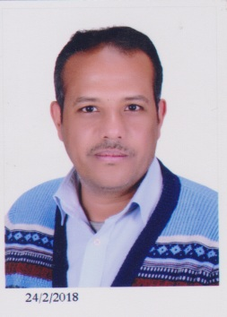

Mohamed El Mursi

Contact Home Address (Aswan)
Information

Home Address (Sohag)

Mail Address (Egypt)

Office
Mobile
Emails

Nationality

Nationality number

Date of Birth

Place of Birth

Citizenship

Academic websites

Flat 16
Building 44
El Sail El Gadeed
Aswan City
Aswan Governorate, Egypt

Flat 2
Building 2
El Shaeek El Sharway
Sohag city
Sohag Governorate, Egypt

Mathematics Department
Faculty of science
Sohag University

00201207699492
m_elmursi@yahoo.com
m_elmursi@science.sohag.edu.eg
fedmursiex@gmail.com

Egyptian

27608082800514

08\08\1976

Aswan- Egypt

Egyptian

www.researchgate.net/profile/Mohamed_Elmursi

http://genealogy.math.uni-bielefeld.de/id.php?id=168438

https://arxiv.org/abs/1411.0504

www.mathjournals.org/jot/2016-075-002/2016-075-002-004.html

www.theta.ro/jot/archive/2016-075-002/index_2016-075-002.html

http://rgmia.org/v20.php

http://rgmia.org/papers/v20/v20a143.pdf

http://www.memphis.edu/msci/rtota2018/index.php

http://www.memphis.edu/msci/icomas2018/

